Prompt
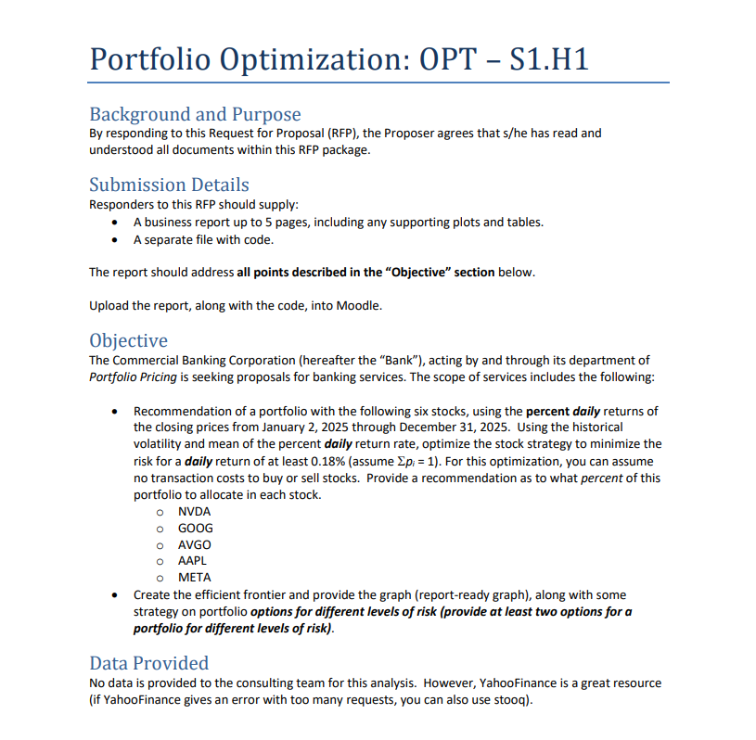

Breakdown
Breakdown here

Report

Report is subtab

Code and Plots
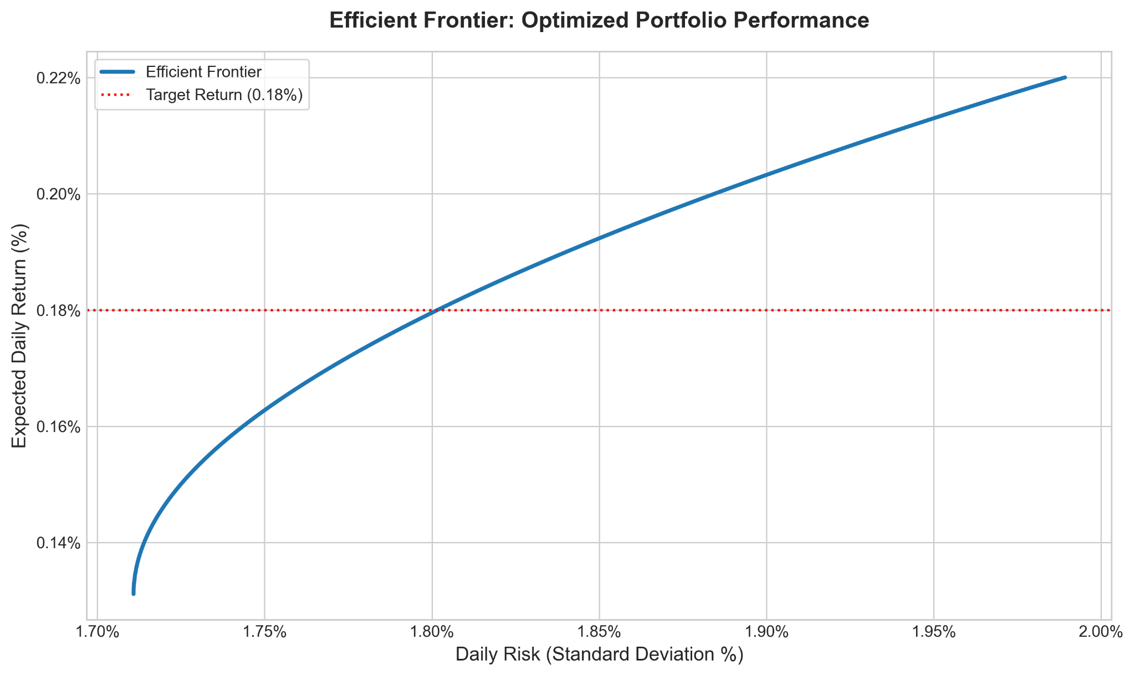

Table 1: Optimal stock portfolio allocation to minimize risk.
Stock | Percentage of Portfolio
Alphabet Incorporated (GOOG) | 43.02%
Apple Incorporated (AAPL) | 34.78%
Meta Platforms Incorporated (META) | 19.49%
Broadcom Incorporated (AVGO) | 0%
NVIDIA Corporation (NVDA) | 0%
Estimated Risk: 1.71% | Estimated Daily Return: 0.1312%

Table 2: Optimal stock portfolio with balanced risk and expected daily return.
Stock | Percentage of Portfolio
Alphabet Incorporated (GOOG) | 71.24%
Apple Incorporated (AAPL) | 15.80%
Meta Platforms Incorporated (META) | 10.38%
Broadcom Incorporated (AVGO) | 1.49%
NVIDIA Corporation (NVDA) | 1.10%
Estimated Risk: 1.80% | Estimated Daily Return: 0.1798%

Table 3: Optimal stock portfolio allocation to maximize daily returns.
Stock | Percentage of Portfolio
Alphabet Incorporated (GOOG) | 91.64%
Broadcom Incorporated (AVGO) | 5.09%
NVIDIA Corporation (NVDA) | 3.18%
Meta Platforms Incorporated (META) | 0.09%
Apple Incorporated (AAPL) | 0%
Estimated Risk: 1.99% | Estimated Daily Return: 0.22%

Report Here

Bank Portfolio Optimization

Team 4
Lukman Awad, Irvin Carreon, Seamus Flaherty, April Groce, Grayson Nico

March 13, 2026

Table of Contents

Overview 1
Methodology 1
Data Used 1
Optimization 1
Analysis 1
Model Creation & Selection 1
Results & Recommendations 2
Fully Optimized Results 2
Additional Recommendations 3
Conclusion 4

Bank Portfolio Optimization

Overview
The Commercial Banking Corporation (hereafter the “Bank”), acting by and through its Portfolio Pricing Department, has requested a recommendation for a stock portfolio. The Bank wishes to include the following five stocks:

- NVIDIA Corporation (NVDA)
- Alphabet Incorporated (GOOG)
- Broadcom Incorporated (AVGO)
- Apple Incorporated (AAPL)
- Meta Platforms Incorporated (META)

Our team optimized the proportions of these five stocks according to risk, using historical volatility and mean of the percent daily return rate, assuming no transaction costs. As a result, we present three portfolio options that aim to maximize returns and minimize risk for the Bank. Two of the portfolios achieve at least the Bank’s target daily return rate of 0.18%, and the third option slightly sacrifices return rate in favor of minimizing risk.

Methodology
The following section describes the structure and preparation of the data used to optimize the Bank’s stock portfolio and create an efficient frontier.

Data Used
Our team collected percent daily returns of closing stock prices for NVDA, GOOG, AVGO, AAPL, and META. Using Yahoo Finance as the source, we gathered data from January 2, 2025 through December 31, 2025. We conducted our analysis using the mean of the percent daily return rate.

Optimization
To prepare our optimization strategy, we implemented constraints in accordance with the Bank’s request and calculated the covariance matrix to represent historical volatility and stock correlation. We paid special consideration to solutions that resulted in a mean daily return rate of at least 0.18%. We also made the assumption that the Bank intends to invest 100% of their allotted budget, neither borrowing money nor setting any aside.

Analysis
This section details how we optimized the portfolio and calculated our efficient frontier.

Model Creation & Selection
To optimize the portfolio, we developed an optimization model in Gurobi. The model defines five continuous decision variables, each representing the proportion of the portfolio allocated to a given stock.

We used the covariance between stocks to define the objective function as $\sum_{i = 1}^{n}{}\sum_{j = 1}^{n}{}p_{i}σ_{ij}p_{j}$. This model has two constraints:

- The sum of the proportions must be equal to 1.
- The daily return must be at least 0.18%.

In addition to the base model, we iteratively optimized for target returns ranging from 0.05% to 0.22%. Each specific return value yielded a different portfolio, which created our efficient frontier. This efficient frontier produced three recommended portfolio strategies:

- A minimum risk portfolio with an estimated risk of 1.71% and a 0.13% expected return.
- A moderate risk portfolio with an estimated risk of 1.80% and a 0.18% expected return.
- A maximum return portfolio with an estimated risk of 1.99% and a 0.22% expected return.

This allowed us to go beyond one simple optimal solution and present different strategies based on the Bank’s risk to return tolerances.

Results & Recommendations
This section describes multiple strategies to increase expected returns and decrease risk on the Bank’s stock portfolio.

Fully Optimized Results
Based on our optimization analysis, we recommend three potential investment strategies for the Bank’s stock portfolio. Table 1 shows the stock portfolio that optimally minimizes risk while meeting all of the Bank’s requirements. Notably, this portfolio achieves an estimated daily return of 0.18%.

Table 1: Optimal stock portfolio with balanced risk and expected daily return.
Stock | Percentage of Portfolio
Alphabet Incorporated (GOOG) | 71.24%
Apple Incorporated (AAPL) | 15.80%
Meta Platforms Incorporated (META) | 10.38%
Broadcom Incorporated (AVGO) | 1.49%
NVIDIA Corporation (NVDA) | 1.10%
Estimated Risk: 1.80% | Estimated Daily Return: 0.18%

By focusing investments in GOOG, with a smaller investment in AAPL and META, we estimate that the Bank will see 1.80% risk, which is the minimum amount possible with these stocks and an estimated daily return of at least 0.18%.

Additional Recommendations
In order to provide more options for the bank, we created an efficient frontier to plot the tradeoffs between risk and return for optimized portfolio performance. The efficient frontier is shown in Figure 1.


Figure 1: Efficient Frontier for Optimized Portfolio Performance

As seen in the quadratic efficient frontier graph, expected daily return increases as risk increases. Our recommended portfolio in Table 1 sits at the intersection of the efficient frontier and the red dotted line that marks an expected daily return of 0.18%.

This efficient frontier also allows us to suggest higher risk and lower risk portfolios for the Bank’s consideration. If the Bank is especially interested in minimizing risk, we recommend the portfolio described in Table 2.

Table 2: Optimal stock portfolio allocation to minimize risk.
Stock | Percentage of Portfolio
Alphabet Incorporated (GOOG) | 43.02%
Apple Incorporated (AAPL) | 34.78%
Meta Platforms Incorporated (META) | 19.49%
Broadcom Incorporated (AVGO) | 0%
NVIDIA Corporation (NVDA) | 0%
Estimated Risk: 1.71% | Estimated Daily Return: 0.13%
By removing investments from AVGO and NVDA and instead focusing on GOOG, AAPL, and META, the Bank will be able to reduce estimated risk to 1.71%. However, this minimum risk comes at a cost: the estimated daily return for the minimal risk portfolio is 0.13%, which falls below the Bank’s request for a return rate of 0.18%. Therefore, the Bank should only choose this portfolio if they are more interested in minimizing risk than maximizing returns.

Our team also presents a portfolio option that maximizes returns, detailed in Table 3.

Table 3: Optimal stock portfolio allocation to maximize daily returns.
Stock | Percentage of Portfolio
Alphabet Incorporated (GOOG) | 91.64%
Broadcom Incorporated (AVGO) | 5.09%
NVIDIA Corporation (NVDA) | 3.18%
Meta Platforms Incorporated (META) | 0.09%
Apple Incorporated (AAPL) | 0%
Estimated Risk: 1.99% | Estimated Daily Return: 0.22%

By allocating 91.64% of funds to GOOG, the Bank has the potential to reach a daily return rate of 0.22%. If the Bank prefers an aggressive investment strategy, this portfolio produces an estimated risk of 1.99%, but with higher estimated returns than both the risk-minimizing portfolio and the balanced portfolio.

Conclusion
Our analysis provides three portfolio strategies. Across all three, GOOG shows up as the largest share, ranging from 43.02% to 91.64%. This may reflect GOOG’s high daily return and low volatility. On the minimum risk profile, GOOG (43.02%), APPL (19.49%), and META (34.78%) hold all the shares, while AVGO and NVDA do not receive any shares. This ranking also occurs in our moderate risk portfolio, where GOOG (71.24%), APPL (15.80%), and META (10.38%) show up as our top three allocations; AVGO (1.49%) and NVDA (1.10%) show up last. Meanwhile, AVGO (5.09%) and NVDA (3.18%) are ranked second and third on our maximum return portfolio with high risk, indicating that they are riskier stocks with ambitious returns. This portfolio also leans heavily on GOOG (91.64%) to provide stability.

Ultimately, we recommend the balanced risk portfolio described in Table 1, as it minimizes risk while achieving the Bank’s requested 0.18% return rate. Our efficient frontier helped us identify two other strategies in the case that the Bank is interested in more aggressively minimizing risk or maximizing returns. Regardless of portfolio strategy, our team recommends investing heavily in GOOG and reducing investments in NVDA and AVGO. This strategic allocation balances high-growth potential with foundational stability to minimize exposure to market volatility.

HW Report Checklist

Homework Report Checklist - Team 4

As instructed by Hiya and Dr. Egan Warren, the team member(s) responsible for checking each item should enter their initials in the field next to each question. All items should be addressed before submitting the assignment with the initialed checklist attached.

Sections & Structure

Overview
LA | Is the overview concise?
LA | Does it provide context about the business problem? <Content>
LA | Does it briefly address your team’s work, quantifiable results, and recommendations? <Action>
LA | Does it offer audience-centered reasons for recommendations? <Context>

Body Sections
AG | Does the report body include information on methods, analysis, quantifiable results, and  recommendations?
AG | Is content grouped into appropriate sections (methodology, analysis, results, recommendations)?

Conclusion
AG | Does the report have a conclusion?
AG | Does the conclusion sum up the report and emphasize relevant takeaways?

Structure
AG | Does each major section have a heading?
AG | Are sections, subsections, and paragraphs organized logically for easy navigation?

Visuals

Introduction, Discussion, and Captions
SJF | Is each visual introduced in the text before it appears?
SJF | Is each visual close to where it is introduced?
SJF | Does each visual include a title with the following information: type (table or figure), number, and a  descriptive caption?
SJF | Is each visual discussed and interpreted in the text?
SJF | Are figures and tables numbered separately?
SJF | Are table captions above the table? Are figure captions below the figure?

Visual Design
SJF | Do figures/tables use audience-friendly labels rather than variable names?
SJF | Are the visuals easy to interpret?
SJF | Are the visuals appropriately sized?
SJF | Do tables appear on one page (not split between 2 pages)?
SJF | Are legends and axis labels included for figures?
SJF | Are numbers in tables right aligned?
SJF | Are the visuals designed well (ex: re-created in Word or Excel, not blurry or stretched,…)?

Document Design

Title Page Design
IC | Does it include a descriptive title?
IC | Does it state the team name, team members’ names, and the submission date?

Table of Contents Design
IC | Does it list all the major sections of the report with corresponding page numbers?
IC | Do the page numbers and sections in the Table of Contents match the report?

Document Design for Entire Report
IC | Is a standard typeface (Calibri, Arial, etc.) used?
IC | Is the size of the body text between 10-12 pt.?
IC | Are headings and subheadings used to organize information?
IC | Are distinctive text styles (bold, italic, etc.) used to distinguish between heading levels?
IC | Are text styles for headings used consistently (ex: all level-one headings are bold)?
 | Are all paragraphs an appropriate length (fewer than 12 lines)?
IC | Is white space used to indicate paragraph breaks?
IC | Are bullet lists used for a series of items and numbered lists to show a hierarchy?

Writing Style and Mechanics

Spelling and Capitalization
GN | Are spelling errors located and corrected?
GN | Is spelling consistent throughout (no switching between acceptable spellings)?
GN | Is capitalization used appropriately (proper nouns, etc.)?
GN | Is capitalization of words consistent throughout the report?

Grammar and Punctuation
GN | Are verb tenses used appropriately?
GN | Are marks of punctuation used appropriately?
GN | Is subject-verb agreement used in every sentence?
GN | Is the grammar checker updated and are underlined grammar issues addressed?

Writing Style
GN | Are all sentences in the report easy for your audience to understand quickly?
GN | Are most sentences written in active voice?
GN | Are idioms and vague words eliminated from the report?
GN | Are acronyms introduced before being used?
GN | Are well-written topic sentences included at the beginning of each paragraph?
GN | Are lists parallel?
GN | Is the appropriate point of view used when addressing your audience or describing team actions?

